The National University of Lesotho
Department of Mathematics and Computer Science
Faculty of Science and technology

CS4433: Software Engineering
Task: Phase 2: Requirements Engineering

Due: 02/10/2026
Participants:
 | Student Number | Surname, initials | Major
 | 202322467 | Lephoto L. | B. Sc. Information Systems

Stakeholder analysis
Stakeholder | Needs / interests | Influence
Principal / school leadership | Simple, usable system; students must not see marks before HoD checks them. | High
Lecturers | Create assignments, set deadlines and maximum marks, grant individual extensions, mark work and give feedback. | High
Heads of Department (HoDs) | Review all departmental marks before release; apply consistent late-work policy; moderate marks. | High
Students / student representative | View enrolled courses and assignments, submit and resubmit before deadlines, receive released marks and written feedback; late work should not simply be rejected. | High
IT officer / school technician | Offline operation, protected passwords, responsive performance with 800 students stored, manageable installation and support. | High
System administrator | Manage user accounts, departments, courses, lecturer assignments and student enrolments. | High
Supervisor / assessor | Evidence of traceable requirements, justified engineering decisions, verification and validation, and consistency across artefacts. | Medium

2. Conflicts, ambiguities and proposed resolutions
Issue | Conflict / ambiguity | Proposed resolution
When students may see marks | Lecturer wants immediate visibility after marking; Principal requires HoD checking first. | Marks remain hidden from students until a HoD approves and releases them. Lecturer marking changes status to Marked; HoD moderation is a separate step.
Late submissions | HoD proposes a 10% deduction of available marks per late day for up to three days, then zero; students object to automatic rejection. | Accept submissions up to three calendar days after the deadline unless an approved extension changes the effective deadline. Apply a penalty of 10 percentage points of the maximum available mark per late day; after three days the mark is zero. HoD/school must confirm whether '10%' means percentage points or 10% of the earned mark.
Extensions | Lecturers need discretion to grant individual extensions; the late policy needs a clear effective deadline. | A lecturer may grant an individual extension for a student enrolled in the course. Record who granted it, the revised deadline, time and reason. Apply lateness rules against the revised deadline.
Resubmission | Students want to correct mistakes before the deadline; the number of submissions is unspecified. | Permit resubmission until the effective deadline; the latest valid submission replaces the previous active submission, while prior versions and timestamps are retained for audit. Confirm whether resubmission is also permitted during an extension.
Who may change marks | HoDs moderate marks, but the exact edit/return workflow is unspecified. | Lecturer enters a mark and feedback; HoD can approve or return it for correction with a recorded reason. Every mark change records actor, timestamp, old value, new value and reason.
Offline operation and multiple users | System must work offline and respond quickly with 800 students, but deployment is a single computer or local network. | Design for local storage and no internet dependency. Treat 800 as the number of student records to be stored; define a measurable performance test using a documented test environment. Concurrent multi-user access requires testing if deployed over a network.
Security and password protection | Passwords must be protected, but exact authentication and recovery rules are not given. | Store salted password hashes using a recognised password-hashing library; never store plaintext passwords. Restrict actions by role and validate permissions in the business layer, not only in the UI.

3. Software Requirements Specification (SRS)

3.1 Functional requirements
ID | Name | Requirement statement | Priority | Verification
FR-01 | Authentication | The system shall authenticate a user using a unique username and password before granting access to protected functions. | Must | Attempt login with valid, invalid and inactive accounts; only valid active accounts enter the system.
FR-02 | Role-based access | The system shall enforce permissions for Administrator, Lecturer, HoD and Student roles for every protected operation. | Must | For each role, test allowed and denied operations, including direct business-layer calls.
FR-03 | Account management | The Administrator shall create, update, deactivate and view user accounts, assigning each account one authorised role. | Must | Create/update/deactivate test cases; deactivated users cannot log in.
FR-04 | Department and course management | The Administrator shall create and update departments and courses and assign each course to a department. | Must | Verify stored records and reject invalid or duplicate identifiers.
FR-05 | Lecturer assignment | The Administrator shall assign a lecturer to a course and change that assignment. | Must | Verify only authorised administrators can change assignments and the course shows the current lecturer.
FR-06 | Student enrolment | The Administrator shall enrol a student in a course and view that course's enrolment list. | Must | Enrolment appears in the course list; duplicate enrolment is rejected.
FR-07 | Assignment creation | A Lecturer shall create an assignment for an assigned course with a title, description, deadline and maximum mark greater than zero. | Must | Reject missing required fields, invalid deadlines and non-positive maximum marks.
FR-08 | Individual extension | A Lecturer shall grant an individual student an extension for an assignment and record the revised deadline and reason. | Must | Verify permissions, saved revised deadline and audit details.
FR-09 | Assignment and course viewing | A Student shall view only courses in which they are enrolled and assignments associated with those courses. | Must | Compare visible lists for enrolled and non-enrolled students.
FR-10 | Submit assignment | A Student shall submit work for an assignment in which they are enrolled, and the system shall record the submission timestamp and status. | Must | Valid submission is saved with timestamp and initial status; unauthorised or invalid submissions are rejected.
FR-11 | Resubmission | A Student shall be able to resubmit before the effective deadline, and the system shall identify the latest valid submission while retaining previous submission history. | Must | Submit twice before deadline; latest is active and earlier version remains in history.
FR-12 | Late-work handling | The system shall calculate lateness against the effective deadline and apply the agreed late penalty, including the zero-mark rule after the permitted late period. | Must | Test on-time, just-late, one-, two-, three-day and beyond-three-day boundaries; exact day-count convention must be confirmed.

4.2 Non-functional requirements
ID | Quality attribute | Measurable requirement | Priority / verification
NFR-01 | Performance | With 800 student records and a representative test dataset, 95% of login attempts shall complete within 2 seconds on the documented target school computer. | Must  Verification: Automated/manual timing test; record hardware, dataset and 95th percentile.
NFR-02 | Offline operation | All core functions—login, course/assignment viewing, submission recording, marking, moderation and release—shall operate without an internet connection. | Must  Verification: Disconnect internet and execute a defined end-to-end test.
NFR-03 | Password security | The database shall contain no plaintext passwords; passwords shall be stored as salted hashes produced by a recognised password-hashing library. | Must  Verification: Inspect schema and stored values; review hashing implementation.
NFR-04 | Data integrity | The database shall enforce primary keys, foreign keys and required constraints; a submission or mark transaction that fails shall not leave a partial update. | Must  Verification: Run constraint tests and inject a failure during a transaction.
NFR-05 | Usability | A representative first-time user in each role shall complete the three core tasks for that role using the supplied user guide, with at least 4 of 5 test participants completing each task without assistance. | Should  Verification: Usability test with recorded tasks, participants and completion results; adapt participant count if access is limited and document the limitation.
NFR-06 | Maintainability/build | A clean checkout shall build using the documented CMake procedure and C++17 compiler without manual source edits. | Must  Verification: Build on a clean environment following the installation/build guide.
NFR-07 | Auditability | Every successful mark change shall create an audit record containing actor, timestamp, old mark, new mark and reason; the audit record shall be committed atomically with the mark update. | Must  Verification: Test normal change and forced transaction failure.
NFR-08 | Access control | Unauthorised role-operation attempts shall be denied and shall not alter persistent data. | Must  Verification: Run a role-operation permission matrix and compare database state before and after denied attempts.
.

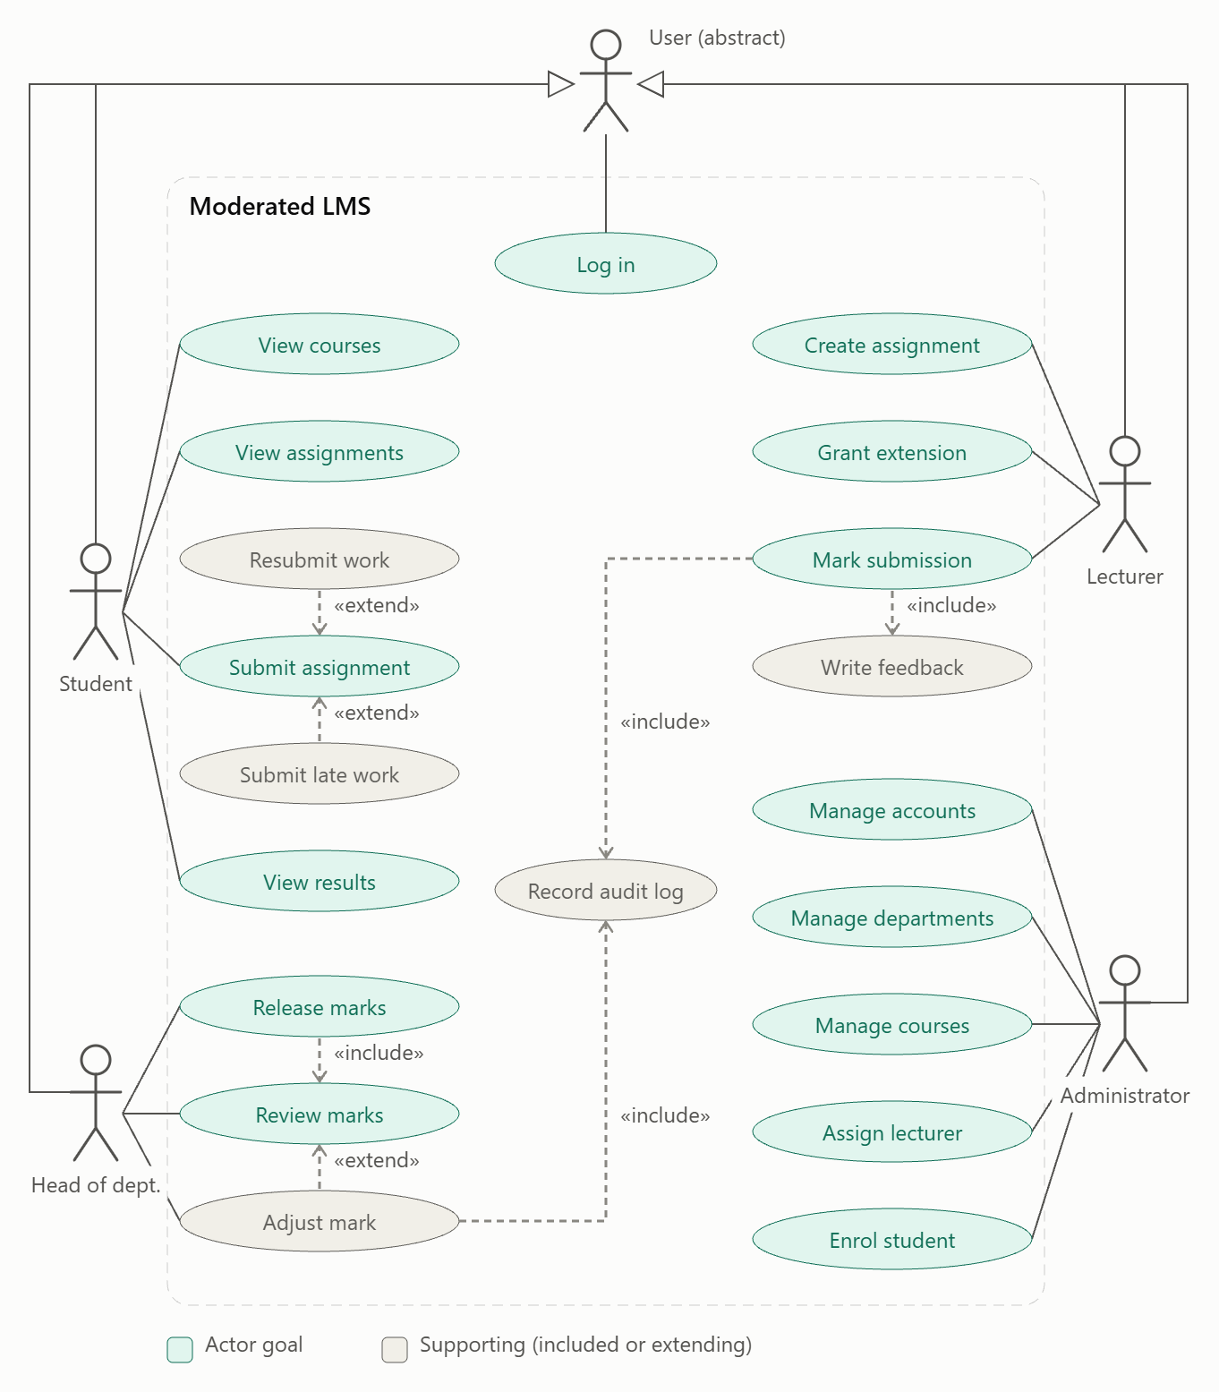
5. Use case model

UC-01: Submit assignment
Field | Content
ID / Name | UC-01 Submit assignment
Primary actor | Student
Supporting actors | None (the system clock is an internal dependency)
Goal | Submit work for an assignment so it can be marked
Trigger | The student selects “Submit” on an assignment in their assignment list
Priority | Must
Preconditions
- The student is logged in (UC Log in completed) with the Student role.
- The student is enrolled in the course that owns the assignment.
- The assignment exists and has a deadline and maximum mark.
Main flow (on-time first submission)
- The student opens their assignment list and selects an assignment.
- The system shows the assignment details, the effective deadline (including any extension) and the student’s current submission status.
- The student selects “Submit” and provides the work (file path or text, depending on your design).
- The system validates the input (not empty, within the size limit, allowed type).
- The system compares the current time with the effective deadline and finds it on time.
- The system stores the submission with a timestamp and sets its status to Submitted.
- The system displays a confirmation with the timestamp and the effective deadline.
Alternative flows
- A1: Resubmission before the deadline (at step 2, a submission already exists and the effective deadline has not passed).
  - The system warns that the new submission will replace the existing one.
  - The student confirms and continues from step 3.
  - At step 6 the system replaces the file, keeps the previous version’s timestamp in the history, and the status stays Submitted.
- A2: Late submission (at step 5, the effective deadline has passed).
  - The system calculates days_late = ceil(hours late / 24).
  - The system tells the student the work is late and that a penalty will apply.
  - The student confirms and the system stores the submission with status Late. The penalty is applied at marking time (UC-02), not now.
  - The flow continues at step 7, and the confirmation states that the work is late.
- A3: Submission with an individual extension (at step 5, the lecturer has granted this student an extension). The system uses the extended deadline as the effective deadline and treats the work as on time if it is before that deadline.
Exception flows
- E1: Invalid input (step 4): the system rejects the submission, shows the reason, and the student corrects it. No data is stored.
- E2: Late by more than 3 days: the system still accepts the work as Late and warns the student that it will receive zero. It is never rejected.
- E3: Resubmission after the deadline: the system refuses and tells the student that resubmission is only allowed before the deadline.
- E4: Student not enrolled / assignment not found: the system denies access and logs the attempt.
- E5: Database failure: the system shows a generic error, rolls back the transaction, and keeps the previous submission intact.
Postconditions
- Success: exactly one current submission exists for the (student, assignment) pair, with a timestamp and status Submitted or Late. Previous versions are retained in the history.
- Failure: no change is made to stored data.
Business rules
- BR1: Only enrolled students may submit.
- BR2: Resubmission is allowed only before the effective deadline.
- BR3: Late work is accepted, never rejected.
- BR4: Penalty is 10% of the assignment’s maximum mark per started day late, for days 1 to 3, and the mark is zero from day 4 onward. It is applied at marking time.
- BR5: The effective deadline is the individual extension if one exists, otherwise the assignment deadline.
- BR6: Submission time comes from the server clock, never from user input.

UC-02: Mark submission
Field | Content
ID / Name | UC-02 Mark submission
Primary actor | Lecturer
Includes | Write feedback, Record audit log
Goal | Assign a mark and written feedback to a student’s submission
Trigger | The lecturer opens a submission from the list of submissions for their assignment
Priority | Must
Preconditions
- The lecturer is logged in and is assigned to the course that owns the assignment.
- The submission exists with status Submitted or Late, or Marked (when re-marking before moderation).
Main flow
- The lecturer selects an assignment and the system lists its submissions with their status.
- The lecturer opens a submission.
- The system displays the work, the submission time, the maximum mark and the late status.
- The lecturer enters a raw mark.
- The system validates that 0 ≤ raw mark ≤ maximum mark.
- The lecturer writes feedback (include Write feedback).
- The system calculates the final mark by applying the late-penalty rule (BR4 of UC-01) to the raw mark.
- The system shows the raw mark, the penalty and the final mark for confirmation.
- The lecturer confirms.
- The system saves the mark and feedback, sets the status to Marked, and writes an audit entry (include Record audit log).
- The system confirms and returns to the submission list.
Alternative flows
- A1: Re-marking (the status is already Marked and not yet moderated). The lecturer enters a new mark. The system requires a reason, then continues from step 6. The audit entry records the old value, new value and reason.
- A2: On-time work. The penalty is zero and steps 7–8 show no deduction.
- A3: Save as draft. The lecturer leaves the mark unconfirmed. The status is unchanged and nothing is visible to the student.
Exception flows
- E1: Mark out of range or non-numeric (step 5): the system rejects it with a message showing the valid range.
- E2: Feedback empty: the system will not confirm until feedback is given (the student rep asked for written feedback).
- E3: Submission already Moderated or Released: the system blocks the change. Only the HoD can adjust the mark (UC-03).
- E4: Lecturer not assigned to the course: access is denied and logged.
- E5: Database or audit-log failure: the whole transaction rolls back, so a mark never changes without an audit entry.
Postconditions
- Success: the submission has a final mark and feedback, status Marked, and the mark is not visible to the student. An audit entry exists (who, when, old value, new value, reason).
- Failure: no mark or audit data changed.
Business rules
- BR1: A lecturer can only mark submissions in their own courses.
- BR2: Marking never makes the mark visible to students. Only HoD release does (resolves Principal vs Lecturer).
- BR3: Feedback is mandatory.
- BR4: Final mark = max(0, raw mark − 10% × max mark × days_late), or 0 if days_late > 3.
- BR5: Every mark change, including the first one, is audited. A reason is required for any change after the first mark.

UC-03: Moderate and release marks
Field | Content
ID / Name | UC-03 Moderate and release marks
Primary actor | Head of Department (HoD)
Includes | Review marks (inside Release marks)
Extended by | Adjust mark, which includes Record audit log
Goal | Check all marks in the department and release approved marks to students
Trigger | The HoD selects “Review marks” for a course or assignment
Priority | Must
Preconditions
- The HoD is logged in and heads the department that owns the course.
- At least one submission has status Marked.
Main flow
- The HoD selects a course in their department.
- The system lists the Marked submissions with raw mark, penalty, final mark, lecturer and feedback (include Review marks).
- The HoD reviews the marks and approves the batch or selected submissions.
- The system sets the approved submissions to Moderated.
- The HoD selects “Release”.
- The system asks for confirmation, showing how many marks will become visible to students.
- The HoD confirms.
- The system sets the submissions to Released and records the release time and releasing user.
- The students can now see their marks and feedback.
Alternative flows
- A1: Adjust a mark (extend Adjust mark, at step 3). The HoD selects a submission and enters a new final mark and a mandatory reason. The system validates the range, saves it, and writes an audit entry (old value, new value, reason, who, when). The HoD then continues the review.
- A2: Return to lecturer. The HoD rejects a submission with a comment. The status goes back to Submitted/Late so it can be re-marked.
- A3: Partial release. The HoD releases only some of the Moderated submissions. The rest stay Moderated.
Exception flows
- E1: No Marked submissions: the system shows “nothing to review”.
- E2: Adjusted mark out of range or reason missing: the system rejects the change.
- E3: Course not in the HoD’s department: access is denied and logged.
- E4: Concurrent change (the lecturer re-marks while the HoD reviews): the system detects the changed version and asks the HoD to reload before approving.
- E5: Database failure on release: the transaction rolls back, so no student sees a partial release.
Postconditions
- Success: the approved submissions have status Released, are visible to the students with feedback, and any adjustment has an audit entry.
- Failure: statuses and marks are unchanged, and no marks are visible to students.
Business rules
- BR1: No mark reaches a student before HoD release (Principal’s requirement).
- BR2: The HoD can see every mark in their department and only their department.
- BR3: Every adjustment needs a reason and an audit entry.
- BR4: Release is irreversible for students. Any later correction creates a new audit entry and a notification (state your rule here).
- BR5: Released marks can only change through an HoD adjustment.

